LT SPICE SIMULATION
- Transient Analysis
Based on the circuit,
When K = 0Ω
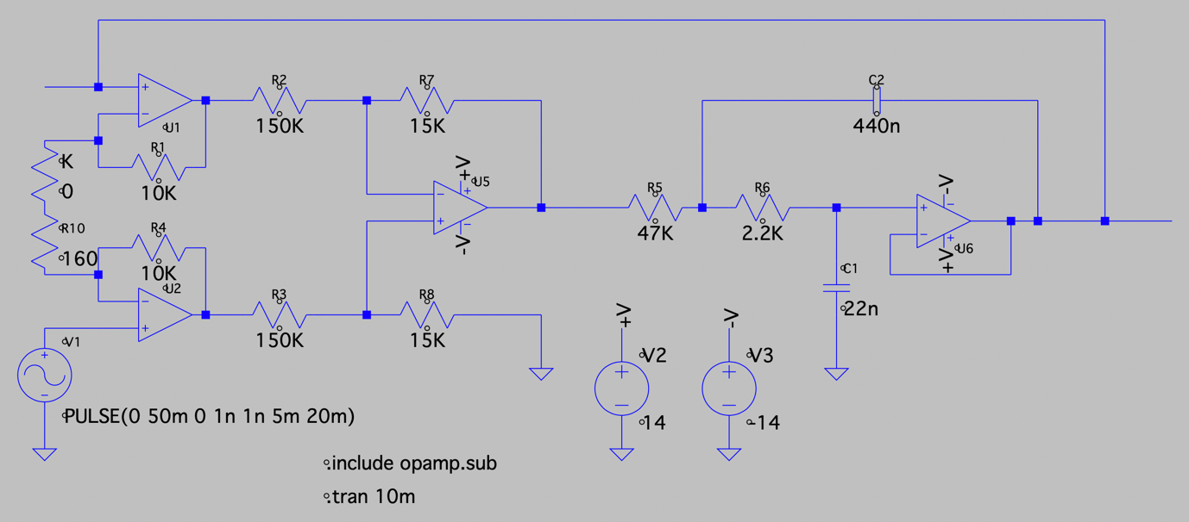
Transient Graph:
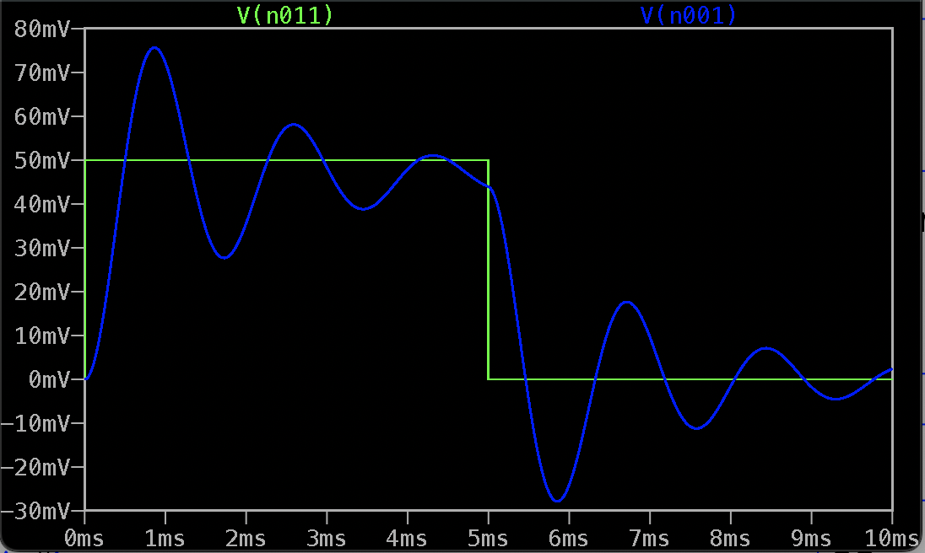

Mp = $\frac{75.97-50}{50}=0.5194$
Tp = 0.89ms
ωd = $\frac{π}{tp}= \frac{π}{0.00089}=3529.88 rad/s$
ωn = $\frac{d}{1- ^{2}}= 3683.36 rad/s$
ζ = $\frac{-ln⁡(Mp)}{\sqrt{π^{2}+\ln^{2}(Mp)}}=0.20413$

When K = 1KΩ
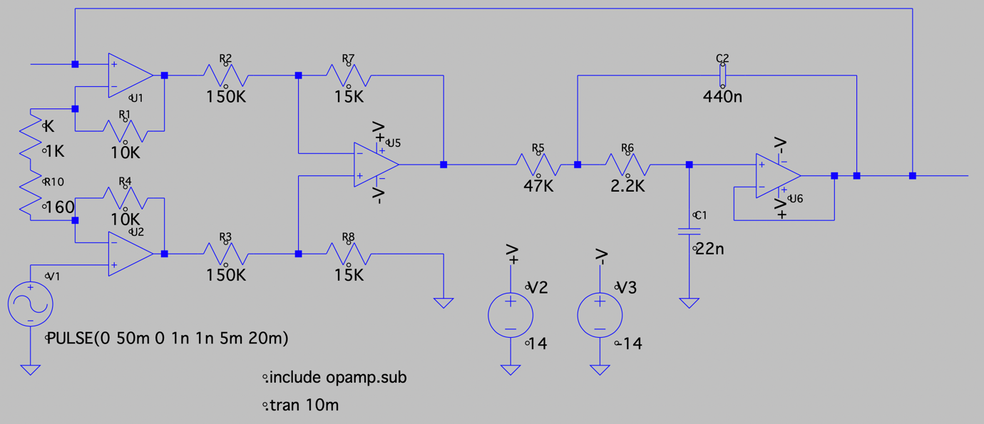
Transient Graph:
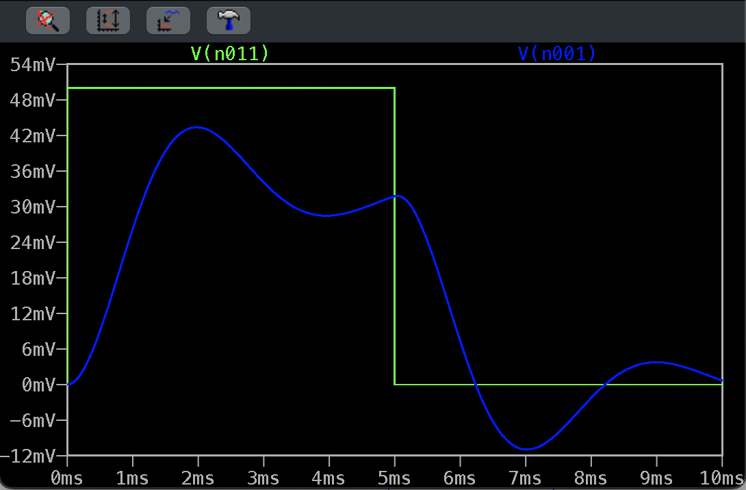

Mp = $0$
Tp = 0
ωd = $\frac{π}{tp}= \frac{π}{0.00089}=$
ωn = $\frac{d}{1- ^{2}}=$
ζ = $\frac{-ln⁡(Mp)}{\sqrt{π^{2}+\ln^{2}(Mp)}}=$

When K = 2062Ω
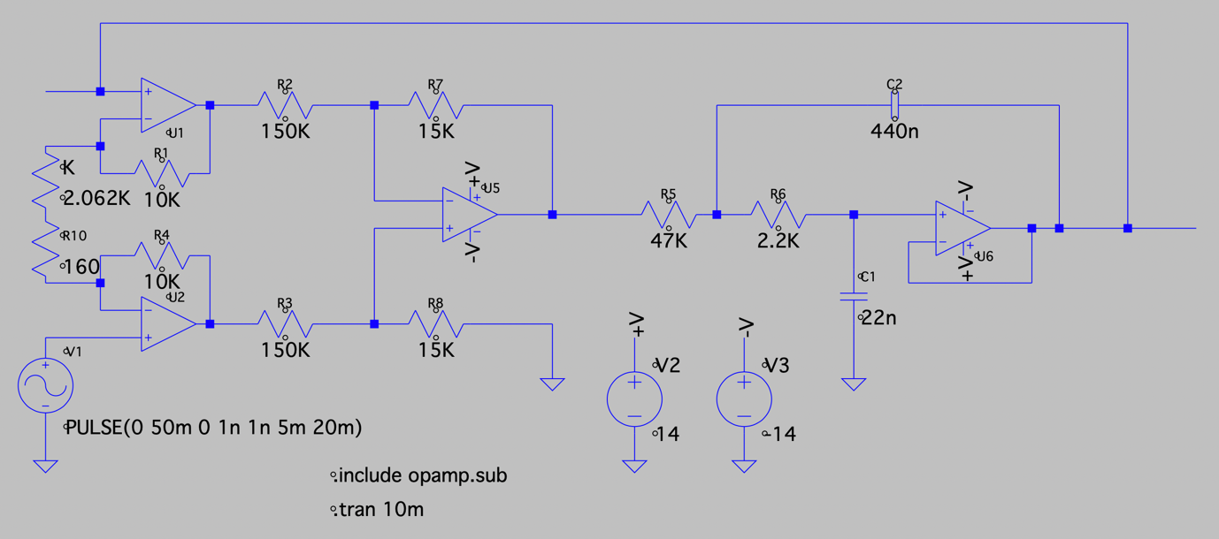
Transient State:
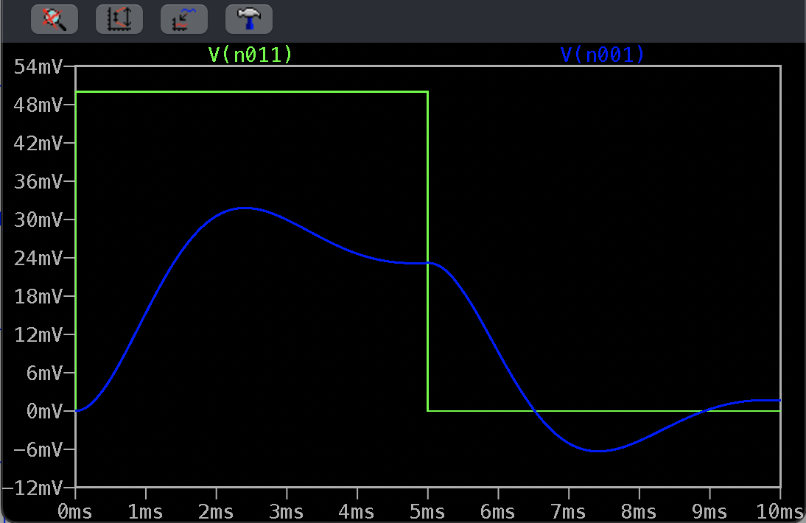

Mp = $0$
Tp = 0
ωd = $\frac{π}{tp}= \frac{π}{0.00089}=$
ωn = $\frac{d}{1- ^{2}}=$
ζ = $\frac{-ln⁡(Mp)}{\sqrt{π^{2}+\ln^{2}(Mp)}}=$

- A.C Analysis
When K=1000Ω
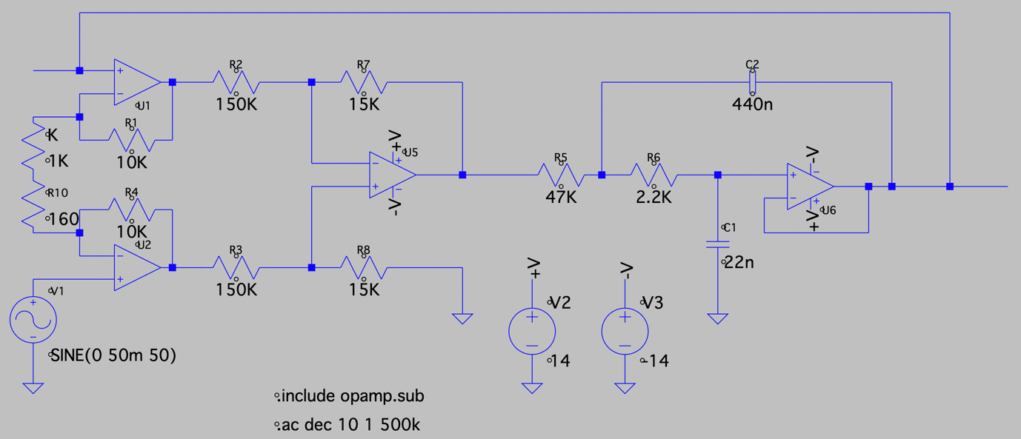
Bode Plot:
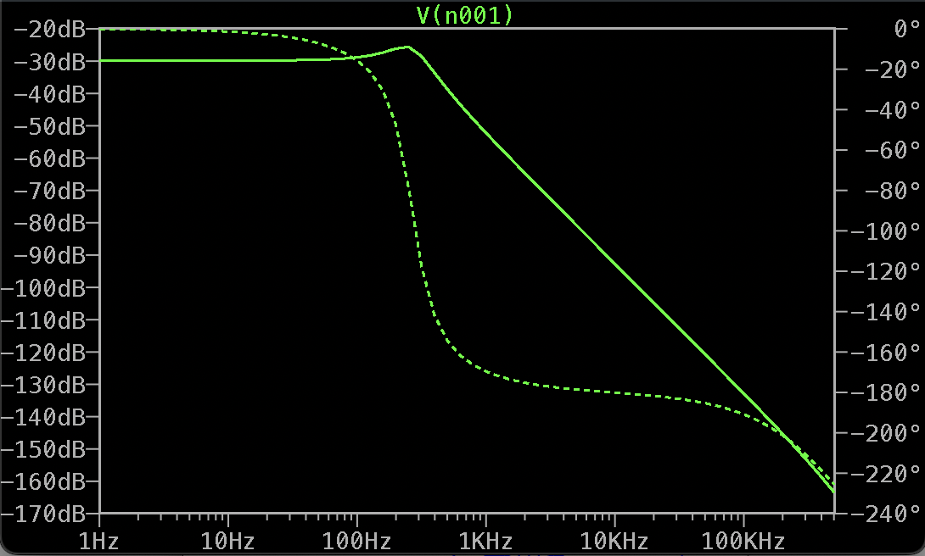

Interpretation:

